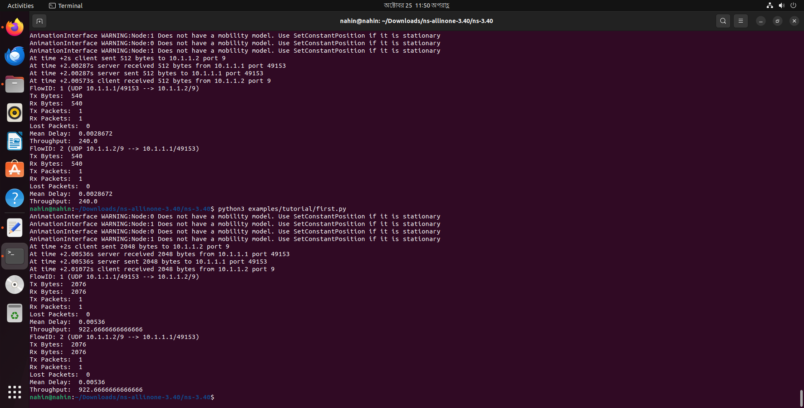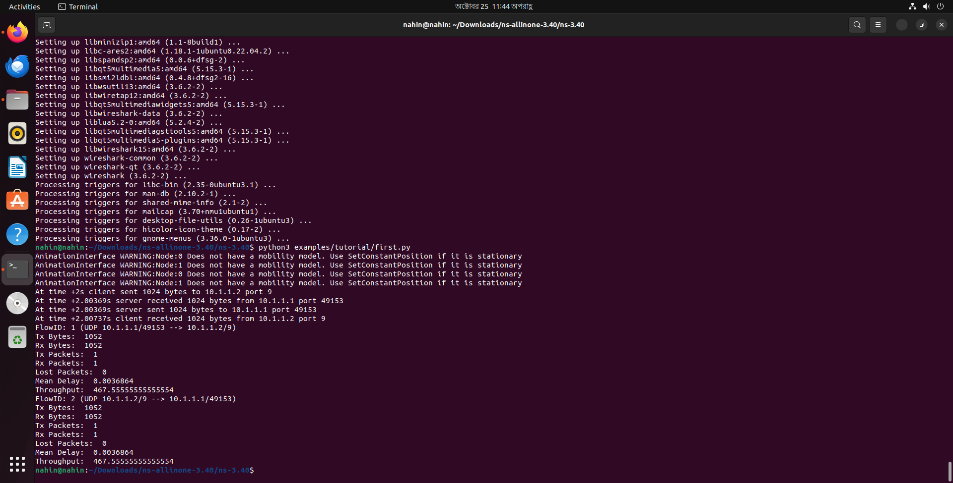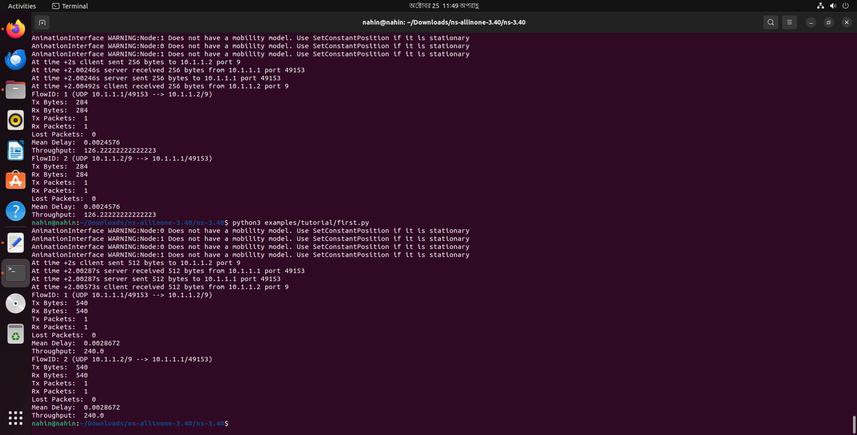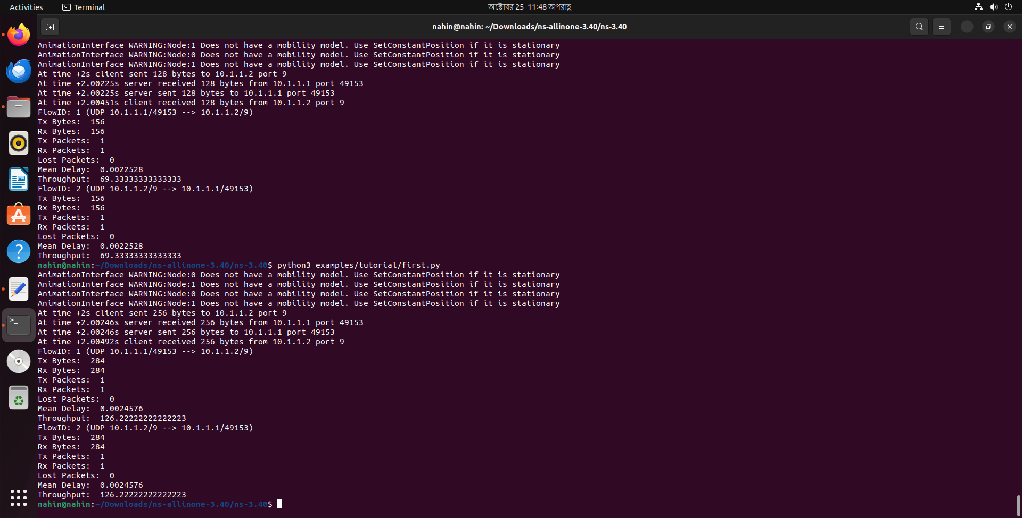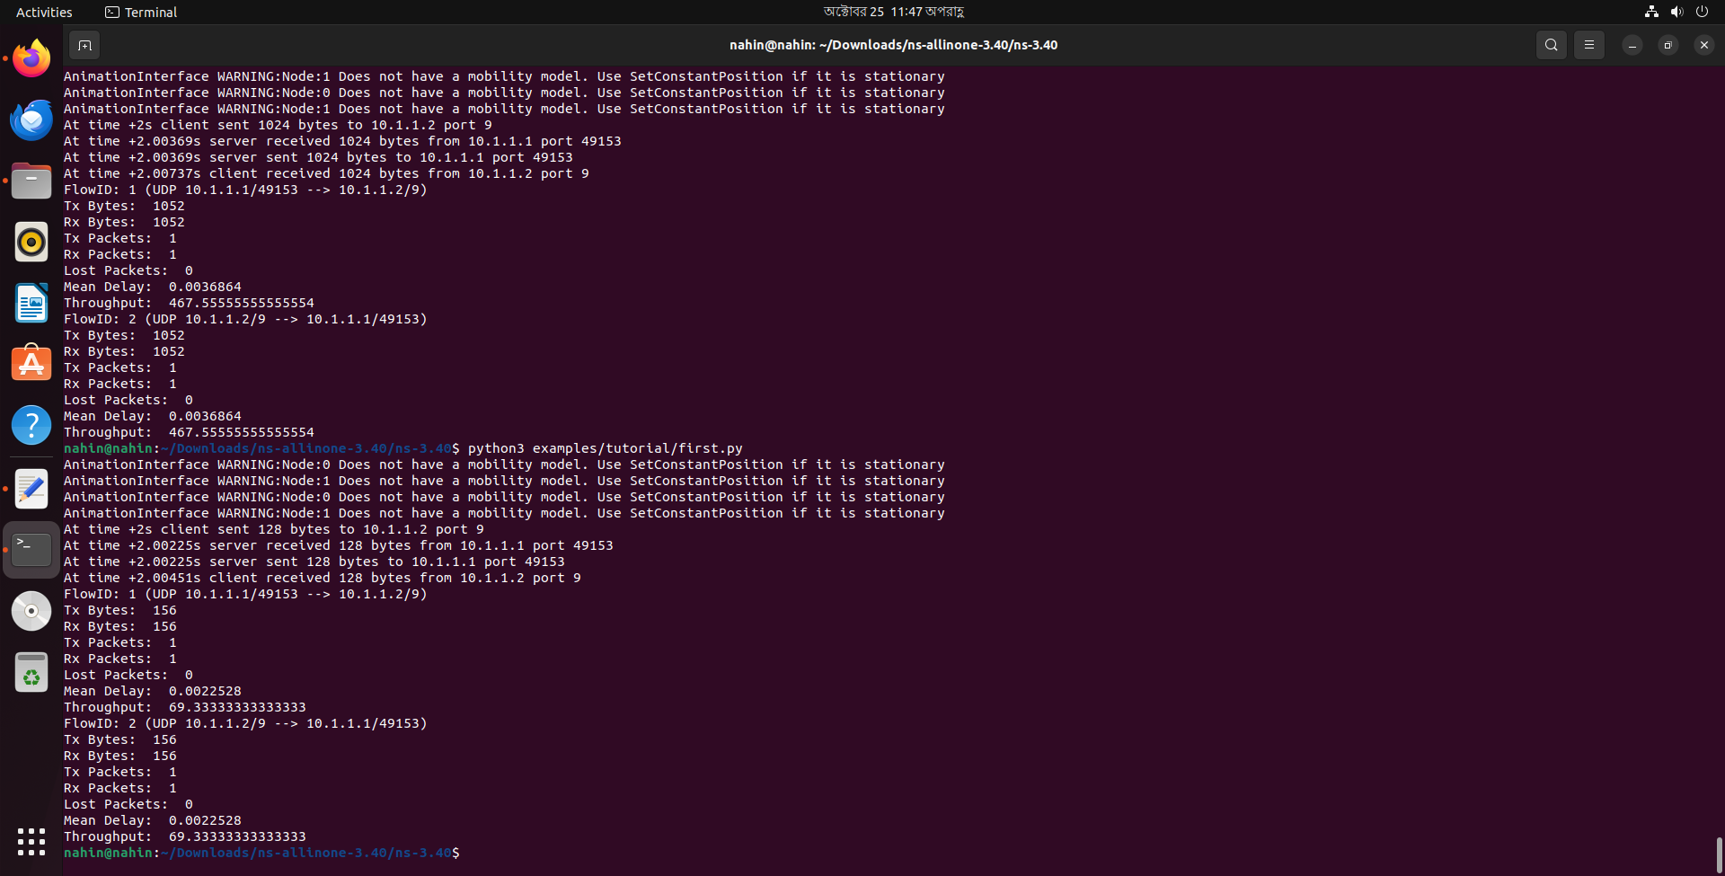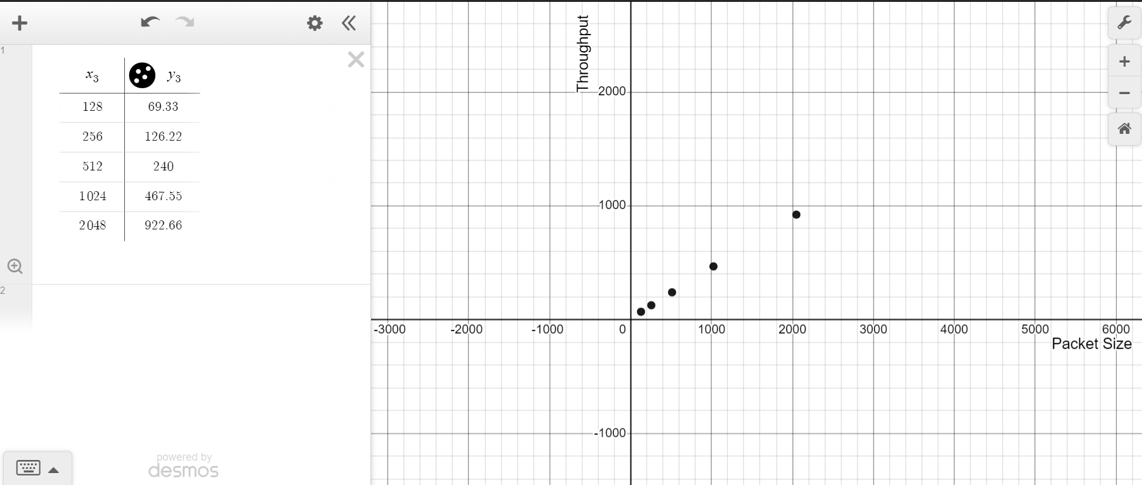

The graph displays a relationship between "Packet Size" (on the x-axis) and "Throughput" (on the y-axis). The data points are plotted in a quadrant with positive x and y values. As the packet size increases, the throughput also increases, indicating a positive correlation between the two variables. Additionally, there's a table on the left side that lists specific values for packet size (`x₃`) and the corresponding throughput values (`y₃`). The data suggests that as the packet size doubles, the throughput doesn't quite double, but it does increase. The graph uses a Cartesian coordinate system with grid lines to assist in reading values.